Devin Hardy

00076619

CS423

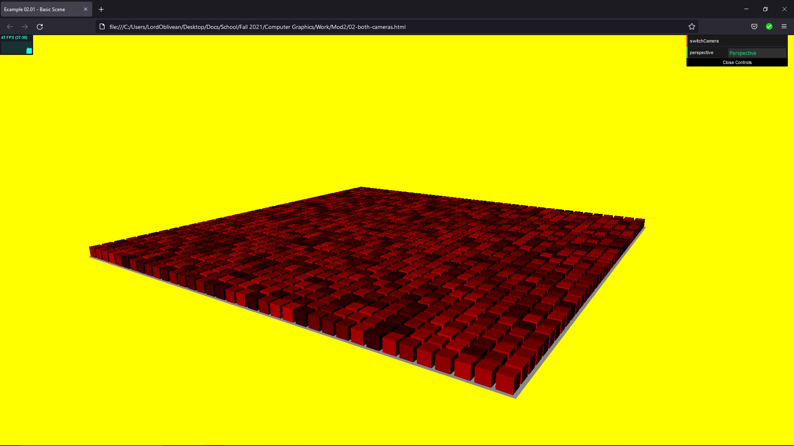

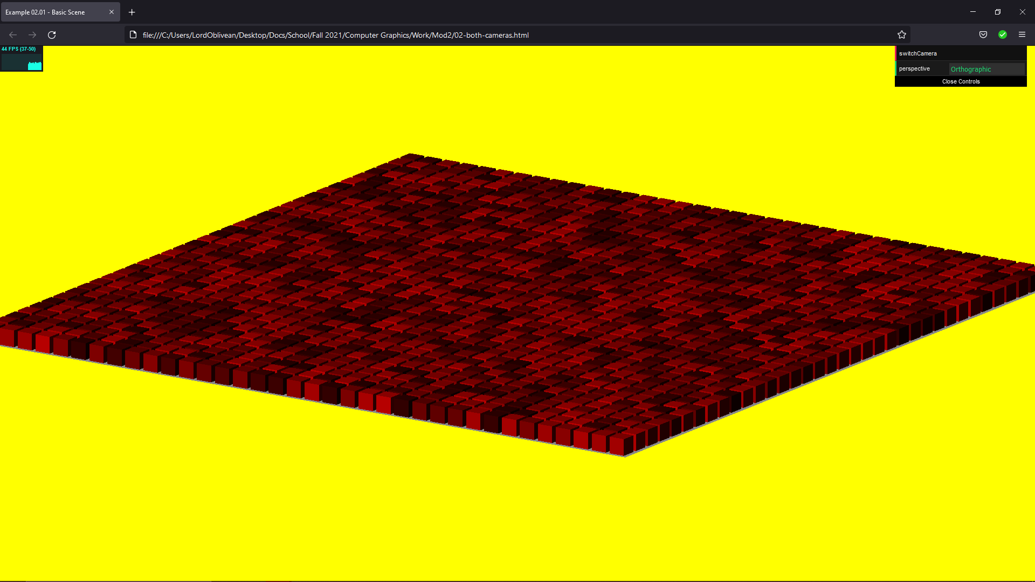

The camera appears to be bending and stretching the cubes.

<!DOCYTPE html>

<HTML>

<HEAD>

<TITLE>Example 02.01 - Basic Scene</TITLE>

<SCRIPT TYPE="text/javascript" SRC="../libs/three.js"></SCRIPT>

<SCRIPT TYPE="text/javascript" SRC="../libs/stats.min.js"></SCRIPT>

<SCRIPT TYPE="text/javascript" SRC="../libs/dat.gui.min.js"></SCRIPT>

<STYLE>

body {

/\* set margin to 0 and overflow to hidden, to go fullscreen \*/

margin: 0;

overflow: hidden;

}

</STYLE>

</HEAD>

<BODY>

<DIV id="Stats-output">

</DIV>

<!-- DIV which will hold the Output -->

<DIV id="WebGL-output">

</DIV>

<!-- Javascript code that runs our Three.js examples -->

<SCRIPT TYPE="text/javascript" SRC="02-both-cameras.js">

</SCRIPT>

</BODY>

</HTML>

//

// File:

// Author:

// Purpose:

//

function init() {

var stats = initStats();

// create a scene, that will hold all our elements such as objects, cameras and lights.

var scene = new THREE.Scene();

// create a camera, which defines where we're looking at.

var camera = new THREE.PerspectiveCamera(45, window.innerWidth / window.innerHeight, 0.1, 1000);

camera.position.x = 120;

camera.position.y = 60;

camera.position.z = 180;

// create a render and set the size

var renderer = new THREE.WebGLRenderer();

renderer.setClearColor(new THREE.Color(0xEEEEEE, 1.0));

renderer.setSize(window.innerWidth, window.innerHeight);

// create the ground plane

var planeGeometry = new THREE.PlaneGeometry(180, 180);

var planeMaterial = new THREE.MeshLambertMaterial({color: 0xffffff});

var plane = new THREE.Mesh(planeGeometry, planeMaterial);

// rotate and position the plane

plane.rotation.x = -0.5 \* Math.PI;

plane.position.x = 0;

plane.position.y = 0;

plane.position.z = 0;

// add the plane to the scene

scene.add(plane);

var cubeGeometry = new THREE.BoxGeometry(4, 4, 4);

for (var j = 0; j < (planeGeometry.parameters.height / 5); j++) {

for (var i = 0; i < planeGeometry.parameters.width / 5; i++) {

var rnd = Math.random() \* 0.75 + 0.25;

var cubeMaterial = new THREE.MeshLambertMaterial();

cubeMaterial.color = new THREE.Color(rnd, 0, 0);

var cube = new THREE.Mesh(cubeGeometry, cubeMaterial);

cube.position.z = -((planeGeometry.parameters.height) / 2) + 2 + (j \* 5);

cube.position.x = -((planeGeometry.parameters.width) / 2) + 2 + (i \* 5);

cube.position.y = 2;

scene.add(cube);

}

}

var directionalLight = new THREE.DirectionalLight(0xffffff, 0.7);

directionalLight.position.set(-20, 40, 60);

scene.add(directionalLight);

// add subtle ambient lighting

var ambientLight = new THREE.AmbientLight(0x292929);

scene.add(ambientLight);

// add the output of the renderer to the html element

document.getElementById("WebGL-output").appendChild(renderer.domElement);

// call the render function

var step = 0;

// Insert Lab03 code here.

// New Controls

var controls = new function () {

this.perspective = "Perspective";

this.switchCamera = function () {

if (camera instanceof THREE.PerspectiveCamera) {

camera = new THREE.OrthographicCamera(window.innerWidth / -16, window.innerWidth / 16, window.innerHeight / 16, window.innerHeight / -16, -200, 500);

camera.position.x = 120;

camera.position.y = 60;

camera.position.z = 180;

camera.lookAt(scene.position);

this.perspective = "Orthographic";

} else {

camera = new THREE.PerspectiveCamera(45, window.innerWidth / window.innerHeight, 0.1, 1000);

camera.position.x = 120;

camera.position.y = 60;

camera.position.z = 180;

camera.lookAt(scene.position);

this.perspective = "Perspective";

}

};

};

var gui = new dat.GUI();

gui.add(controls, 'switchCamera');

gui.add(controls, 'perspective').listen();

// make sure that for the first time, the

// camera is looking at the scene

camera.lookAt(scene.position);

render();

function render() {

stats.update();

// render using requestAnimationFrame

requestAnimationFrame(render);

renderer.render(scene, camera);

}

function initStats() {

var stats = new Stats();

stats.setMode(0); // 0: fps, 1: ms

// Align top-left

stats.domElement.style.position = 'absolute';

stats.domElement.style.left = '0px';

stats.domElement.style.top = '0px';

document.getElementById("Stats-output").appendChild(stats.domElement);

return stats;

}

}

window.onload = init